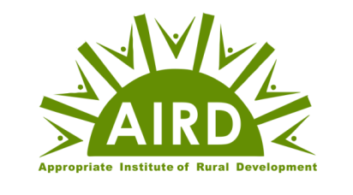

Membership Categories and Subscription

The Appropriate Institute of Rural Development (AIRD) welcomes individuals and institutions who believe in the values of humanity, participatory development, Gram Swaraj, and sustainable rural transformation. Membership is open to students, researchers, professionals, volunteers, social workers, institutions, and all individuals willing to contribute to community development.

Membership Categories
Category | Eligibility | Annual Membership (Rs.) | Life Membership (Rs.)
General Member | Students, villagers, volunteers, and individuals interested in rural development | ₹10 | Not Applicable
Special Member | Professionals, teachers, researchers, development practitioners, and supporters | ₹100 | ₹500
Executive Member | Individuals willing to actively guide, support, and participate in AIRD's programmes and institutional development | ₹1,000 | ₹5,000

Membership Motto
"Join Hands • Learn Together • Serve Together • Build Gram Swaraj"

